**Leader Overview**

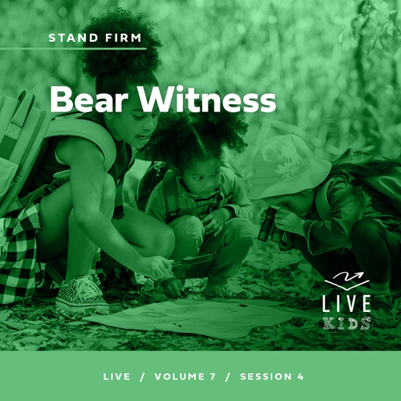

**Volume Overview**

**Stand Firm**

*The world thinks of power as action. Powerful people are able to take control, able to change things. But Jesus blessed the meek, the hungry, and the poor. There is a power this world overlooks. There is power in standing firm in faith. Christians have long stood their ground, not to gain this world’s power but as witnesses to a better world to come. So we stand strong, committed, and bear witness to the world.*

**Session Overview**

**Bear Witness**

*In this* **Live** *session, kids will discover how to live such a bold life for Jesus that even their enemies notice their commitment to Him. When Peter and John were put on trial for their faith, they refused to stop telling others about Jesus. We need to be willing to stand up for Jesus, too. The way we live can help to point others to Him.*

**Bible Lesson**

Peter and John Stand Trial

[Acts 4:1–21](https://ref.ly/logosref/Bible.Ac4.1-21)

**Faith Fact**

I will stand up for Jesus.

**Faith Verse**

[Ephesians 6:13](https://ref.ly/logosref/Bible.Eph6.13) (NLT)

Put on every piece of God’s armor so you will be able to resist the enemy in the time of evil. Then after the battle you will still be standing firm.

**Preparing for the Session**

**Leader Preparation Time: 20–25 Minutes**

|  |
| --- |
| ***You Will Need***  ***Large Group***   * *Bible* * *Worship songs (Song suggestions: “Won’t Stop Now” by Elevation Worship; “Surrounded (Fight My Battles) Lyric Video” by Bethel Music; “Battle Belongs” Lyric Video by Phil Wickham)* * *For groups not using a phone or tablet only, add:*   *• Projector or TV*  *• Laptop*  *•* ***Countdown60 Video****–60 seconds*  *•* ***Faith Fact Slide***  ***• Faith Verse Video*** *or* ***Slide***  ***• Bible Lesson Video***  ***• Teaching Point Slides 1–3***  ***Small Group***   * ***Countdown60 Video****–60 seconds* * *Bibles for kids in the group to share* * *Bible, one per group* * *Smartphone timer* * *Prize, one per group* * ***Small Group Activity Page****, one per kid* * *Pencils, one per kid*   *To access session content and videos from a computer, visit:* [*BibleEngagementProject.com/downloads*](https://bibleengagementproject.com/downloads) |
| ***Getting Ready***  ***Large Group***   * *Download videos and slides if needed.* * *Select worship song(s) and have them ready to play.* * *Read the Bible Lesson Scripture to prepare for Teaching Time.*   ***Small Group***   * *Print copies of the* ***Small Group Activity Page****, one per kid.*   *First time leading Live for* Kids*? Check out the* [*Facilitator Guide*](https://0b769b0ed3569ef9d18b-f88d8272f61086866d50d048b43ef630.ssl.cf2.rackcdn.com/sites/biblengagementproject/Listen_Facilitator_Guide.pdf)*.* |

**Large Group**

**30 Minutes**

*See what’s needed at the beginning of the session.*

**Introduction**

Welcome back! Are you ready to learn one more way to stand firm in our faith in Jesus? *(Group response)* Today is about standing, so let’s begin by standing up together. Ready? Stand up! *(Group response)* Okay, sit down. *(Group response)* Stand up again! *(Group response)* Sit back down. *(Group response)* No, wait, stand up again! *(Group response)* Good job. Let’s stay standing!

Why all the standing up and sitting down? Because I want you to remember the importance of standing up for your faith in Jesus. *(Show the Bible.)* Today, we’ll learn about two of Jesus’ closest disciples. They continued to stand up for Jesus and tell others about Him everywhere they went. They knew it had become their responsibility to stand up for Jesus and tell others about Him since He had gone back to heaven. Now, it’s our responsibility to do the same thing.

**Faith Fact**

Is anyone getting tired of standing yet? *(Group response)* It’s a lot easier to sit down than it is to stand up for a long time. The same thing can be true in life. We might get tired of standing up for Jesus or even be afraid of what others will think about us. That’s why our Faith Fact today is **I will stand up for Jesus.**

• *Show the* ***Faith Fact Slide.***

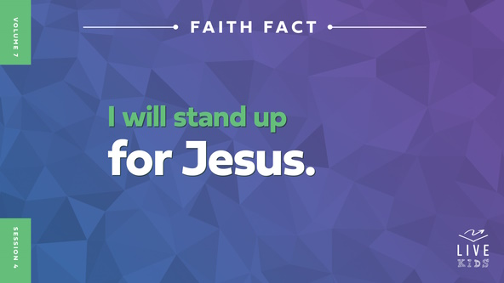

Let’s say the Faith Fact a few more times. Each time we say the Faith Fact, we’ll sit down and stand back up. Ready? **I will stand up for Jesus.**

• *Lead the kids in saying the Faith Fact a few more times while sitting down and standing back up.*

Great job standing up for Jesus! You can sit down now.

**Game**

**Stand Up**

Living for Jesus requires us to stand up for Him and what we believe in. That’s usually a lot easier to do when we’re with other Christians. But God expects us to share our faith in Jesus with others who don’t know Him. It requires a lot of boldness and strength to stand up for Jesus when no one else does. We must be prepared to stand up for what we believe even if we stand alone.

Let’s practice. In today’s game, you’ll stand up if any of the statements I say are true about you. Let’s go.

• *Share different statements all starting with the phrase, “Stand up if …” Kids should be seated after each phrase.*

Stand up if:

• you ate cereal for breakfast.

• you have read an entire book in the Bible before.

• you have a pet fish.

• your favorite ice cream is vanilla.

• you are not wearing tennis shoes right now.

• you have ever eaten pizza for breakfast.

• your family ate dinner together at home last night.

• you ride a bus to school.

• you take your lunch to school every day.

• you have a favorite Bible verse.

• you love apples.

• you ate a peanut butter and jelly sandwich last week.

• you love to read.

• you’ve ever received a letter or birthday card in the mail addressed to you.

• you recognize the names Peter and John from the Bible.

• you will stand up for Jesus!

That was a lot of fun. I hope you learned some things about others in our group. It can be easy to stand up in a game like this. It may not always be easy to stand up for what you believe in, especially when that’s your faith in Jesus. We’ll find out more about that after we sing and worship God together.

**Worship**

Worship doesn’t have to involve singing or standing all the time, but there is something special about standing up, singing, and giving God your full attention in worship. God loves it when we’re willing to stand up and get out of our comfort zone to spend time with Him.

• *Lead the kids in singing one or two praise songs. See suggestions at the beginning of the session.*

**Bible Lesson**

Thanks for standing, singing, and worshipping God with me today. He loves to hear and see our worship. Let’s pray and ask God to give us the boldness and courage to stand up for Him as we learn from His Word today.

**Prayer**

|  |
| --- |
| *Dear God, thank You for giving us so many examples of people who stood up for You in the Bible. Help us to be inspired by their examples to boldly stand up for You, too. Amen.* |

**Video Intro**

Just before we look at the Bible story, let’s check in with Dash and watch this video.

• *Play* ***Bible Lesson Video****.*

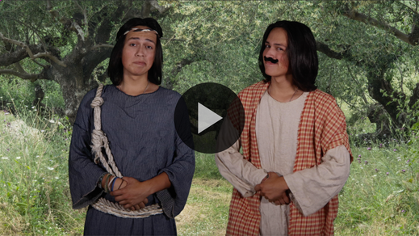

**Bible Story**

**Peter and John Stand Trial**

That video was a great lead-in to our Bible story today! Dash’s uncle showed us what it looks like to put Jesus first in our life. He stood up for his faith in Jesus. Jesus’ first disciples probably had the most reasons to keep standing up for Jesus. They saw His miracles and really got to know Him. Still, we know that one of Jesus’ disciples, Judas, betrayed Jesus, which led to Him being crucified.

After Jesus went back to heaven, His disciples started teaching people about Him, and God used them to perform miracles. It was risky for them. Remember, the religious leaders arrested Jesus and had Him crucified. Some leaders still didn’t like what Jesus stood for, His followers, or the things they told the people. We’ll see how some of the religious leaders reacted to a couple of Jesus’ disciples standing up and sharing the good news in today’s Bible story.

**Teaching Time**

After being filled with the Holy Spirit, Jesus’ disciples were bold! They had to be bold and brave to continue the mission Jesus had started. They had been with Jesus during His ministry on earth, so they knew what they were facing. The fact that they were teaching out in public tells us that they were willing to do anything to continue sharing about Jesus.

One of the disciples was specifically known for being bold and speaking up when no one else would. Do you know who I’m talking about? *(Allow responses.)* I’m talking about Peter. Peter’s name literally meant “rock,” and Jesus had big plans for Peter’s life. Peter was up for the challenge.

In order to fully understand what is happening in today’s Bible story, we need to look back at what happened in [Acts 3](https://ref.ly/logosref/Bible.Ac3). Peter and John were heading to prayer service at the temple one day when a man who couldn’t walk asked them for some money. Instead of giving him money, Peter healed him in the name of Jesus.

The temple was a very public place, so a lot of people saw that the man was healed. News quickly spread about the healing, and Peter took the opportunity to preach to the crowd who had gathered. Peter boldly declared that the reason for the man’s healing was because of faith in Jesus. Our Faith Fact reminds us to be bold and stand up for Jesus like Peter did that day. Let’s say it together. **I will stand up for Jesus.**

Let’s read about Peter and John and what happened next as they continued to stand up for Jesus. Grab your Bible or pull up a Bible app on your device. Turn to [Acts 4:1–21](https://ref.ly/logosref/Bible.Ac4.1-21).

• *In order to keep Large Group time moving along, we recommend that the leader reads the Scripture portions aloud.*

• *Optional: Remind the kids to mark this place with their Bible bookmark so they can read it on their own at home.*

**1. Peter and John were arrested for teaching about Jesus.**

• *Show the* ***Teaching Point 1 Slide.***

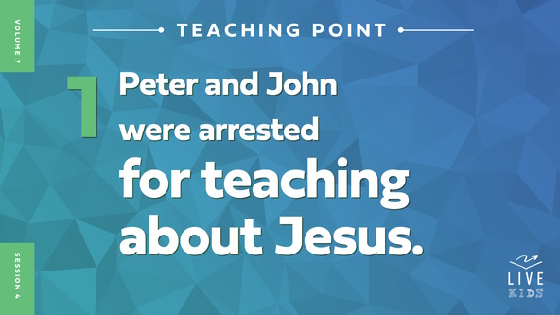

• *Read* [*Acts 4:1–9*](https://ref.ly/logosref/Bible.Ac4.1-9)*.*

How did the religious leaders react when they found Peter and John teaching the people? *(Allow responses.)* The religious leaders were determined to stop the disciples’ preaching, so they put Peter and John in jail until the next day. But before they could arrest the two disciples, thousands of people heard the disciples preach and chose to believe in Jesus.

Have you ever talked about Jesus with someone? *(Group response)* I’m proud of you for sharing your faith and standing up for Jesus. Were you arrested and put in jail for sharing about Jesus? *(Group response)* Not everyone around us will be okay with us talking about Jesus. Maybe we will face punishment for standing up for Jesus at some time. We should be thankful for the freedom we do have and share about Jesus as often as we can.

**2. Peter boldly stood up for Jesus.**

• *Show the* ***Teaching Point 2 Slide.***

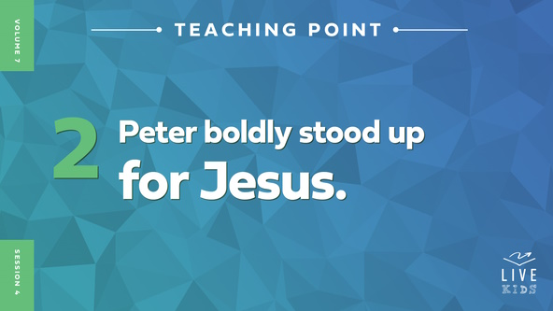

• *Read* [*Acts 4:10–14*](https://ref.ly/logosref/Bible.Ac4.10-14)*.*

Imagine you were Peter and John. You were on the way to a prayer service. God healed a man who couldn’t walk after you asked Him to heal the man. That gave you the opportunity to tell a lot of people about Jesus. Then, you were arrested and put in jail. Raise your hand if you might think about giving up after that. *(Group response)*

Even after being arrested, Peter boldly spoke against the religious leaders and stood up for Jesus. Peter didn’t want anyone to think for even a second that he or John had healed the man who couldn’t walk by their own power. Peter told them that the man had been healed in Jesus’ name. Peter blamed them for putting Jesus to death. How do you think Peter was able to speak with so much boldness when he was faced with being put in jail or worse? *(Allow responses.)* Peter had been filled with the Holy Spirit’s power.

The religious leaders could see Peter and John’s boldness and knew that it couldn’t possibly be coming from them alone. They could tell that the boldness was because Peter and John had been close to Jesus. But they still wanted to punish Peter and John for what they had done. Had Peter and John done anything wrong? *(Group response)* No, the religious leaders had no good reason to punish them. The proof of the miracle God had performed through the two disciples was undeniable. The man who had been healed was right in front of the religious leaders.

People love to see proof that something is real or exists. For example, how do we know the wind exists? *(Allow responses.)* We can feel it and see how it affects other things. How do we know gravity exists? *(Allow responses.)* None of us is floating around. The man who had been healed was Peter and John’s proof that the Holy Spirit’s power was at work through them.

**3. Peter and John refused to stop talking about Jesus.**

• *Show the* ***Teaching Point 3 Slide.***

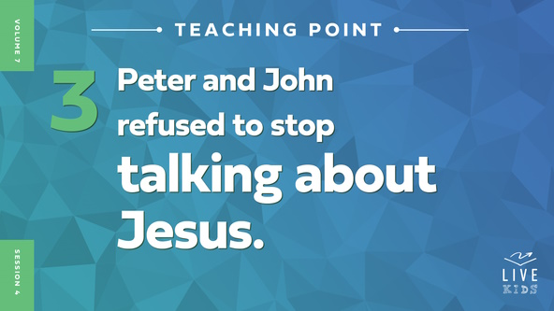

• *Read* [*Acts 4:15–21*](https://ref.ly/logosref/Bible.Ac4.15-21)*.*

The religious leaders knew they shouldn’t put Peter and John back in jail. After all, the people had seen the miracle the disciples had performed. The leaders had another idea. They thought that they could at least keep Peter and John from continuing to teach people about Jesus. They tried to make them be quiet and stop talking about Jesus.

• *Sit down as you say it.*

Do you think they scared Peter and John? *(Group response)* It doesn’t sound like it! When the religious leaders told them to never teach about Jesus again, Peter and John refused to obey them. Even though these men were powerful religious leaders, Peter and John stood up to them. They refused to stop telling people about Jesus and everything they had seen and heard. How could they possibly keep all the amazing things Jesus said and did to themselves? The religious leaders continued to threaten them but they continued to stand up for Jesus.

• *Stand back up again*.

There was nothing the leaders could threaten to do that would have convinced Peter and John stop talking about Jesus to people. He was too great, and His message was too powerful to keep to themselves.

**Prayer and Response**

*Consider playing a worship song softly in the background while kids pray.*

The same Jesus that Peter and John shared about is the Jesus we believe in today. The same Jesus that they boldly stood up for is the Jesus we should stand up for today. We may not face as big of a threat, but not everyone is going to like what we have to say about Jesus or agree with us either.

Should we just stop sharing about Jesus and sit back down if we are rejected or made fun of when we talk about Jesus? *(Group response)* No! We must continue to share boldly about Jesus and stand up for Him like Peter and John. Let’s stand up, link arms, and pray together for boldness to stand up for Jesus no matter what.

• *Have everyone stand and link arms as you pray.*

**Prayer**

*Optional: Have the kids repeat phrases of the prayer after you.*

|  |
| --- |
| *Dear Jesus, thank You for teaching me the importance of standing up for You. Help me to be bold like Peter was about sharing my faith and love for You with others. Amen.* |

**Faith Verse**

Our Faith Verse reminds us to put on the armor of God. When we put on the armor of God, we have everything we need to stand up for Jesus. Peter and John definitely used God’s armor to resist their enemies. Let’s say our Faith Verse and do the actions together.

• *Play* ***Faith Verse Video****.*



[Ephesians 6:13](https://ref.ly/logosref/Bible.Eph6.13) (NLT)

Put on every piece of God’s armor so you will be able to resist the enemy in the time of evil. Then after the battle you will still be standing firm.

**Faith Fact**

Before we go to our small groups, let’s say our Faith Fact again. **I will stand up for Jesus.**

• *Show the* ***Faith Fact Slide****.*



Let’s say our Faith Fact together as we stand up straight and tall. **I will stand up for Jesus.** Remember to stand up for Jesus and share your faith with others any chance you get this week.

• *Dismiss kids to Small Group time or to go home if your group time ends here.*

**Small Group**

**30 Minutes**

*This section can be done in conjunction with the large group or on its own if you do small groups with your kids. During Small Group time, the goal is to connect the kids with the Word of God and to each other. All activities are led by the small group leader.*

**Group Connection**

**Where to Stand?**

|  |
| --- |
| ***You Will Need***   * ***Countdown60 Video***   *No prep needed for this activity.* |

We’ll play a fun game that will show us where to stand. You will quickly line up according to a specific category I call out. I’ll give you one minute in get in the correct order. As we do more rounds, I’ll give you less time to get in the correct order.

• *Play the* ***Countdown60 Video*** *and call out a category from the list below.*



• *Here are some suggested categories for each round:*

• *Shortest to tallest*

• *Youngest to oldest*

• *Alphabetical order of first names*

• *Alphabetical order of last names*

• *Shortest to longest hair*

• *Order by date of birth (i.e., start with those born on first day of the month to those born on the last day of the month)*

• *Add other categories if time allows.*

That was a lot of fun! We figured out where to stand based on a specific category. Where we stand isn’t as important as who we stand for. We need to be bold enough to let other people know we stand for Jesus. He will give us the strength and boldness to stand up for Him just like He did for Peter and John.

Note: Game adapted from game on [www.BibleGamesCentral.com.](http://www.biblegamescentral.com/)

**Bible Lesson Recap**

• *If small group activities are not immediately following large group time, you may want to read the Bible story passage before the discussion.*

|  |
| --- |
| ***You Will Need***   * *Bibles for kids in the group to share*   *No prep is needed for this activity.* |

**Bible Story Review: Peter and John Stand Trial** [**Acts 4:1–21**](https://ref.ly/logosref/Bible.Ac4.1-21)

Let’s think about what we remember from the Bible story. Peter and John had just performed an incredible miracle through the power of God in a very public place. They healed a man who had never been able to walk in his entire life. When people gathered around to find out what had happened, Peter took the opportunity to share the good news about Jesus with them. Many people chose to believe in Jesus because of the miracle and Peter’s teaching. Some of the religious leaders heard that they were teaching about Jesus’ resurrection and had Peter and John thrown in jail overnight.

The next day, Peter and John were brought before the leaders to stand trial for what they had done. Had the two disciples done anything wrong? *(Group response)* No! Peter even told the religious leaders what *they* had done wrong—they had killed Jesus.

Peter and John stood up for Jesus. The religious leaders were not happy with them, but they had no grounds to keep them in jail. The religious leaders tried to stop Peter and John from telling more people about Jesus. Do you think it worked? *(Group response)* No way! Peter boldly told the leaders that he and John would continue to share everything they had seen and heard with others. Peter and John stood up for Jesus in the face of being thrown in prison or worse. They refused to stop telling others about Jesus.

• *Give each kid a Bible and read the Bible story together.*

**Group Discussion**

*Feel free to use all or just a few questions as a jumping-off place for good discussion. Questions marked with * are designed for more conversation. Adjust the questions based on the age or maturity of your group. Typically, older kids will be able to dive a little deeper than younger ones.*

**Questions**

Why were Peter and John in trouble?

* Were Peter and John willing to stop teaching about Jesus? Why or why not?

Do you think Peter and John knew it was dangerous for them to tell others about Jesus? Why do you think that?

* Why do you think Peter and John chose to teach in public where anyone could hear them instead of in secret?

How do you think Peter’s response to being arrested affected the religious leaders?

* Do you think the religious leaders were surprised that Peter talked back to them? Why or why not?

* Do you think you could stand up to leaders the way Peter and John did? Why or why not?

When is it hardest for you to stand up for Jesus?

How can you show others that you believe in Jesus?

**Live It**

**Faith Fact**

Our Faith Fact today is **I will stand up for Jesus.** Standing up for Jesus requires boldness and courage. The kind of boldness Peter and John had comes from the power of the Holy Spirit and being committed to Jesus. The Holy Spirit is living inside us if we have chosen to believe in Jesus. He will help us stand up for Jesus, too.

**Challenge**

If you want the boldness and power Peter had in your own life, all you have to do is ask for it. Ask God for the Holy Spirit to fill you with His power. He wants to fill you and send you out with His power to do big, bold things for God. Who knows how many people will come to know Jesus and believe in Him when you are willing to be used by God to stand up for Jesus!

**Prayer**

*Finish group discussion by sharing prayer requests and praise reports. Keep track of your small group’s prayer requests and review them each time you meet.*

• *Have kids share and pray for each other’s prayer requests.*

|  |
| --- |
| *Dear God, help us to be filled with the power of the Holy Spirit every day. Give us boldness to stand up for Jesus. Amen.* |

**Faith Verse Review**

|  |
| --- |
| ***You Will Need***   * *Bible, one per group* * *Smartphone timer* * *Prize, one per group*   *No prep is needed for this activity.* |

Our Faith Verse is [Ephesians 6:13](https://ref.ly/logosref/Bible.Eph6.13). It teaches us how to stand firm in our faith and put on the armor of God.

• *Show* ***Faith Verse Video****.*



[Ephesians 6:13](https://ref.ly/logosref/Bible.Eph6.13) (NLT)

Put on every piece of God’s armor so you will be able to resist the enemy in the time of evil. Then after the battle you will still be standing firm.

Let’s say it together a couple of more times. I hope you know the Faith Verse because someone is going home with a prize today, but you have to know the Faith Verse and be able to say it confidently and quickly!

• *Say the verse as a group a couple of times.*

**Faith Verse Fun**

**Stand Up and Deliver**

You are on your own for this Faith Verse challenge! If you know the verse, stand up. *(Group response)* Anyone who would like to give it a try can share the Faith Verse.

• *Invite kids who are willing to try and say the verse on their own.*

Now, here’s the challenge. Can you stand up and deliver it boldly and fast? I’ll time you saying the Faith Verse individually. The person who says the Faith Verse correctly and the fastest will win a prize. Who is ready to give it a try?

• *Give kids an opportunity to say the verse.*

• *Give a prize to the winner.*

This Faith Verse was a hard one to learn! Congratulations to all of you for doing your best to learn it!

**Activity Page**

**S-T-A-N-D**

|  |
| --- |
| ***You Will Need***   * ***Small Group Activity Page****, one per kid* * *Pencils, one per kid*   ***Getting Ready***   * *Print copies of the* ***Small Group Activity Page****, one per kid.* |

For this Activity Page today, you will be completing an acrostic. Who knows what an *acrostic* is? *(Allow responses.)*

• *Hand out a copy of the* ***Small Group Activity Page*** *and a pencil to each kid.*

An acrostic simply means that you will come up with something for each letter in the word “stand.” You will come up with a way to stand up for Jesus that starts with each letter. When you have finished your acrostic, circle one idea to put into action this week.

• *Help kids to come up with ideas if needed. Talk with them about what they are writing.*

**Dismissal**

I don’t know about you, but reading about Peter and John’s boldness to stand up for Jesus gets me fired up! I want to stand up for Jesus, too. How about you? *(Group response)* Let’s pray and ask Jesus to give us the boldness we need to stand up for Him.

**Prayer**

|  |
| --- |
| *Dear Jesus, thanks for giving us the opportunity to tell others about Your love. Help us to follow the examples of Peter and John and stand up for You. Amen.* |

**Faith Fact Recap**

• *Show the* ***Faith Fact Slide****.*



Remember today’s Faith Fact as you head out today. Say it with me. **I will stand up for Jesus**. We may be at the end of our time together, but it’s only the beginning of our mission to go out and share Jesus with others. Stand firm in your faith in Jesus and tell others about Him.

• *Send home the* ***Small Group Activity Page.***

• *Remind parents that there are* ***Family Devotions*** *available on the app to do with their kid.*

• *Tell everyone the date and time for the next session.*

.